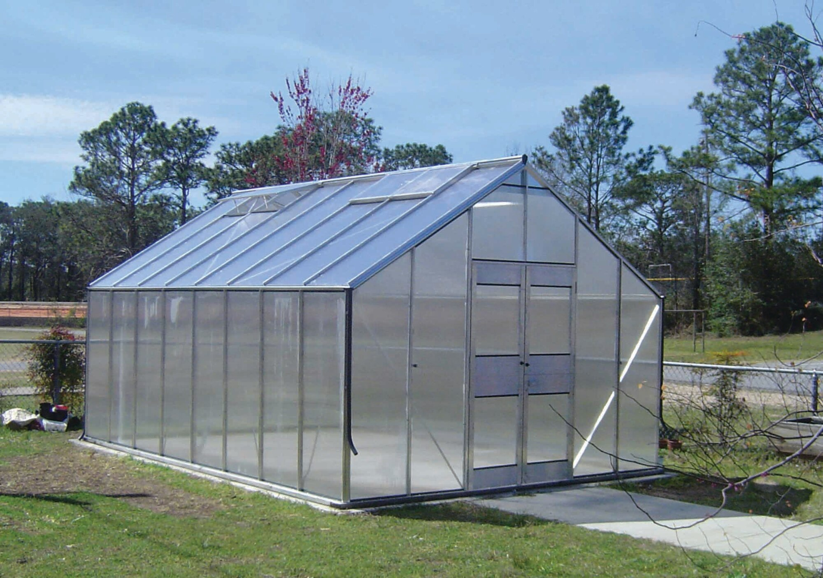
Greenhouse Mgt.
2023-2024
Cosby High School Ag. Dept. /FFA
Mrs. Jennifer Noe
Cosby High School
3318 Cosby Hwy, Cosby, TN 37722
noej@cocke.k12.tn.us
remind app- text code to 81010
Remind app code for students-@2b7ca8 (ALL LOWERCASE)
remind app code for parents/ guardians-@2h63he8 (all lowercase)
google classroom-ocx243z (all lowercase)

Course
Greenhouse Management is an applied-knowledge course designed to prepare students to manage greenhouse operations. This course covers principles of greenhouse structures, plant health and growth, growing media, greenhouse crop selection and propagation, and management techniques. Upon completion of this course, proficient students will be equipped with the technical knowledge
Goals and Objectives:

- Develop good habits, attitudes, judgments, and the ability to participate with others in a work environment
- Create an understanding for the importance of the agriculture industry in its entirety
- Develop student comprehension of science and mathematics content through application in agriculture
- Create a desire in students to seek additional skills and knowledge in a given area of interest

Textbook: google classroom, icev

Grading Procedure:

- Participation/Laboratory Activities – 30%
- Test 50%
- Other assignments (quizzes, worksheets, student notes) 20%
- Pass safety test with 100 accuracy
- Students will work in the greenhouse several times per week, dress accordingly

Classroom Rules:
1. Bring all needed materials to class.
2. Be in your seat and ready to begin when you get off the bus.
3. Be respectful and polite to all people.
4. Speak at appropriate times, using appropriate language.
5. Respect other people’s property.
6. Keep cell phones off/or hidden while in the classroom.
7. Food/Drinks are allowed at appropriate times, but are privileges that can be taken away during class.
8. All safety guidelines will be followed when given.
9. Follow all school and greenhouse rules.
10. NO TOBACCO

Grading Scale (NEW FOR 2022-2023)

90-100 = A; 80-89 = B; 70-79 = C; 60-69 = D; 0-59 = F

***Disclaimer: Assignments may change at any time.

Final Exam Policy

­­As daily attendance at school is critical for academic success, Cosby High School has added an incentive to the academic program to reward individual daily attendance.

- All non-EOC teachers are required to administer a comprehensive final exam that assesses the mastery of standards taught throughout the semester.
- EOC teachers are required to administer a graded quiz or test during the final exam blocks on the dates listed above. EOC quick scores are used in the final exam column and weighted as the final exam. The graded quiz or test will be averaged with the 4th nine weeks grades.
- Exams are given on the last two days of both semesters. The grades on these exams will count 15% of the overall course average.

School Year 2023-2024
Final Exam Dates

Fall 2023
December 14 – 2nd and 4th blocks
December 15 – 1st and 3rd blocks

Spring 2024
May 20 – 2nd and 4th blocks
May 21 – 1st and 3rd blocks
(In the spring, exam dates for seniors are adjusted to allow time to average grades for graduation.)

ALL students in grades 9-12 have an opportunity to earn exemption on the final exam in non-EOC courses and/or final quiz/test given in the EOC courses. Teachers will follow the following guidelines in determining student exam exemption:

- The student has missed no more than 3 days (excused or unexcused) in the semester prior to the first day of finals.
- Absences for a school related activity (field trip, CTE program, athletic competition, etc.) does not count as an absence.
- The student is passing the class prior to the exams.

The student who qualifies for exam exemption may opt to take the exam on a no harm basis. If the exam grade damages the class average, then the exam grade will not count.

Teachers will administer tests in all courses and for all students except for those students who qualify for and accept the exemption.

