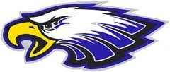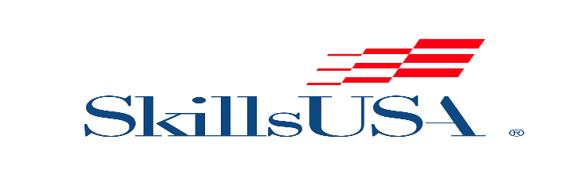

Advanced Manufacturing

Instructor Information: Travis Sane
Cosby High School
3318 Cosby Hwy, Cosby, TN 37722
sanet.cocke.k12.tn.us
Course Description: Advanced Industrial Maintenance is designed to provide students with the knowledge and skills to effectively perform industrial maintenance procedures in an advanced manufacturing facility. Students in this course develop proficiency in a vast array of electromechanical domains, including: fundamental safety practices in electromechanical technology, shielded metal arc welding (SMAW), basic metal inert gas (MIG) welding, electrical systems, AC and DC motors, calibrating instruments, drive systems, pipe fabrication, hydraulic systems, pumps, digital electronics, programmable logic controllers (PLC), and troubleshooting procedures. Upon completion of this course, proficient students will be prepared to pursue postsecondary electromechanical technology programs and entry-level industrial maintenance technology careers in the advanced manufacturing industry. * This course is recommended for 2 credits

Hyperlink to local curriculum, state standards, and/or competencies
cte_std_adv_industrial_maintenance.pdf

Course Content: Course content covers basic quality principles and processes, blueprints and schematics, and systems. Content will also come from academic classes such as Algebra I, Geometry, and Physical Science. Students will work in teams to learn teamwork, students will work individually to focus on problem solving, and how to work in a safe and productive manner to understand productivity.

Major Assignments: In order for students to show competency with course material, students will be asked to complete a course project, as well as classwork (both group and individual), lab work, and reading and writing assignments.

Grading scale:
In Class work = 10% 100 - 90 = A
Lab work = 30% 89 - 80 = B
Test = 50% 79 - 70 = C
Class Participation = 10% 69 - 60 = D
59 - 0 = F

Goals and objectives:
- Develop good habits, attitudes, judgements, and the ability to participate with other students in a work environment
- Create an understanding for the importance of the manufacturing industry in its entirety
- Create a desire in students to seek additional skills and knowledge that can be used throughout their entire career
- Develop student comprehension of science and mathematics content through application in manufacturing

Materials:
- Chromebook
- Writing utensil / Pen (blue or black ink)
- Notebook / Binder

Late Work: Students will have 2 days to turn in all late work after the 2nd day student will receive a 0 or incomplete for the assignment. If a student misses my class it will be their responsibility to ask for the miss or make-up work.
Class Rules :
- ALWAYS BE SAFE AND WORK IN A SAFE MANNER
- ALWAYS WEAR YOUR APPROPRIATE PPE
- ALWAYS BE RESPECTFUL TO OTHER STUDENTS
- NO FOUL LANGUAGE
- NO CELL PHONES / EARBUDS OUT DURING CLASS
- NO NICOTINE ( TOBACCO, CIGARETTES, VAPES, ETC )
- NO TALKING WHEN SOMEONE ELSE HAS THE FLOOR
- ALWAYS LISTEN
- ALWAYS BRING ALL MATERIAL TO CLASS
- BE ON TIME IN SEAT AND READY TO LEARN
- NO FOOD OR DRINK IN CLASSROOM ( EXCEPT WATER )
- RESPECT THE TOOLS / SUPPLIES THEY ARE NOT YOURS

Student Signature_____________________________

Date:_______________

Parent Signature______________________________

Date:_______________

